**Docter G**

Project Phase IV Report

***On***

**Professional Healthcare Mobile App on JAVA**

**Submitted for the requirement of Project course**

BACHELOR OF ENGINEERING

**COMPUTER SCIENCE & ENGINEERING**



## Submitted to: Submitted By:

**Project Teacher: Kirat Kaur**

|  |  |
| --- | --- |
| **NAME:** | **UID:** |
| **Rohan Ghosh** | **20BCS9671** |
| **Jai Budhraja** | **20BCS5816** |
| **Kirti** | **20BCS7083** |
| **Md. Badruddin** | **20BCS5907** |
| **Liza Sharma** | **20BCS7097** |

**E-code: E12999**

## Co Supervisor Signature

(**Ms. Kirat Kaur & E-Code: 12999)**

# DEPARTMENT OF COMPUTER SCIENCE & ENGINEERING CHANDIGARH UNIVERSITY, GHARUAN

**Novemeber 2022**

i

# ABSTRACT

Healthcare mobile apps are becoming a reality for users interested in keeping their daily activities under control. Docter G is an application based upon android development. It aims to provide faster and efficient way to have a proper health service in your hands. The application provides the user to have his/her own data of any disease data here means the reports, medicinal routine, precautions and a data of the nearest hospital and the availability doctors 24/7. Most unique part of the application is that the users get a daily update of the disease viral in air by providing the bets precaution, affected symptoms, and home remedies because prevention is better than cure.

In the last years, several researchers have investigated the effect of healthcare mobile apps on the life of their users as well as the positive/negative impact they have on the quality of life. In doing so, we define a manual process that enables the creation of an extended taxonomy of healthcare users' requests. The results of our study show that users of healthcare apps are more likely to request new features and support for other hardware than users of different types of apps. Moreover, they tend to be less critical of the defects of the application and better support developers when debugging.

# TABLE OF CONTENT

|  |  |  |
| --- | --- | --- |
| **Sr**  **no.** | **Topic** | **Page No.** |
| **1** | Use of Modern tools in design and analysis | 4-5 |
| **2** | Discussion and report/results analysis | 6-10 |
| **3** | Project management and Professional communication  (Presentation) | 11-15 |
| **4** | Attainment of stated outcomes | 16 |
| **5** | References | 17 |

**USE OF MODERN TOOLS IN DESIGN AND ANALYSIS**

According to a recent survey, the digital healthcare market should reach nearly [660 billion USD by 2025](https://www.statista.com/statistics/1092869/global-digital-health-market-size-forecast/). In the past two years, businesses and [digital health investors](https://appinventiv.com/blog/increasing-investment-in-healthcare-technology/) have invested more than 21 billion in digital healthcare projects. Besides the increasing market size, there’s also a surge in overall app usage. Since the outbreak of Covid-19, the number of [healthcare app downloads has increased by 60%](https://www.statista.com/statistics/1181413/medical-app-downloads-growth-during-covid-pandemic-by-country/) worldwide.

Additionally, as per Statista, there were [52,565 healthcare apps](https://www.statista.com/statistics/779919/health-apps-available-google-play-worldwide/) on the Google play store in the first quarter of 2022. On the other hand, there were [51,370](https://www.statista.com/statistics/779910/health-apps-available-ios-worldwide/) healthcare and medical apps ([iOS healthcare app development](https://appinventiv.com/blog/ios-app-development-cost-for-healthcare/))  in the Apple App Store in the first quarter of 2022.

These numbers indicate the growing popularity of mobile health app development. Hence, it’s not surprising to see so many companies and healthcare professionals investing in healthcare mobile application development.

[Digital healthcare](https://appinventiv.com/blog/automation-in-healthcare/) is also widely categorized and leverages the considerable potential of the latest innovative tech trends, like [IoMT (Internet of Medical Things)](https://appinventiv.com/blog/internet-of-medical-things-in-health-sector/), [Big Data](https://appinventiv.com/blog/data-analytics-in-healthcare/), and [AI](https://appinventiv.com/blog/ai-in-healthcare/), for the sake of both patients and healthcare providers. Take an instance from the image below and imagine the business scope in the healthcare market in any prospective field.

## Software and Libraries Requirement:

* JAVA IDE
* JDK

1. **JAVA IDE:**

A Java IDE is an integrated development environment for programming in [Java](https://www.theserverside.com/definition/Java); many also provide functionality for other languages,

IDEs typically provide a code editor, a [compiler](https://www.techtarget.com/whatis/definition/compiler) or interpreter and a debugger that the developer accesses through a unified graphical user interface ([GUI](https://www.techtarget.com/whatis/definition/GUI)). Java IDEs also include language-specific elements such as Ant and Maven [build tools](https://www.techtarget.com/searchsoftwarequality/definition/build-tool) and TestNG and [JUnit](https://www.techtarget.com/searchsoftwarequality/definition/JUnit) [testing](https://www.techtarget.com/whatis/definition/software-testing).

[**NetBeans**](https://www.theserverside.com/definition/NetBeans): a Java-based IDE and underlying application platform framework. In addition to Java, [JavaScript](https://www.theserverside.com/definition/JavaScript) and JavaFX, NetBeans supports C/C++, PHP, [Groovy](https://www.theserverside.com/definition/Groovy), and [HTML5](https://www.techtarget.com/whatis/definition/HTML5)

1. **JDK:**

The Java Development Kit (**JDK**) is a distribution of [Java](https://en.wikipedia.org/wiki/Java_(programming_language)) Technology by [Oracle Corporation](https://en.wikipedia.org/wiki/Oracle_Corporation). It implements the Java Language Specification (**JLS**) and the Java Virtual. Machine Specification (**JVMS**) and provides the Standard Edition (**SE**) of the Java Application Programming Interface (**API**). It is derivative of the community driven [OpenJDK](https://en.wikipedia.org/wiki/OpenJDK) which Oracle steward.[[5]](https://en.wikipedia.org/wiki/Java_Development_Kit#cite_note-5) It provides software for working with Java applications. Examples of included software are the virtual machine, a compiler, performance monitoring tools, a debugger, and other utilities that Oracle considers useful for a Java programmer.

Oracle have released the current version of the software under the Oracle No-Fee Terms and Conditions (**NFTC**) license. Oracle release binaries for the x86-64 architecture for Windows, macOS, and Linux based operating systems, and for the aarch64 architecture for macOS and Linux. Previous versions have supported the [Oracle Solaris](https://en.wikipedia.org/wiki/Oracle_Solaris) operating system and [SPARC](https://en.wikipedia.org/wiki/SPARC) architecture.

Oracle's primary implementation of the JVMS is known as the [HotSpot (virtual machine)](https://en.wikipedia.org/wiki/HotSpot_(virtual_machine)" \o "HotSpot (virtual machine)).

**(Snapshot-1)**

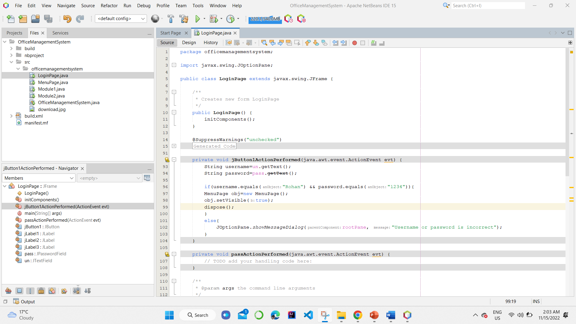Source code of the project i.e., runnable main class.

**(Snapshot -2)**

Login page of the interface.

**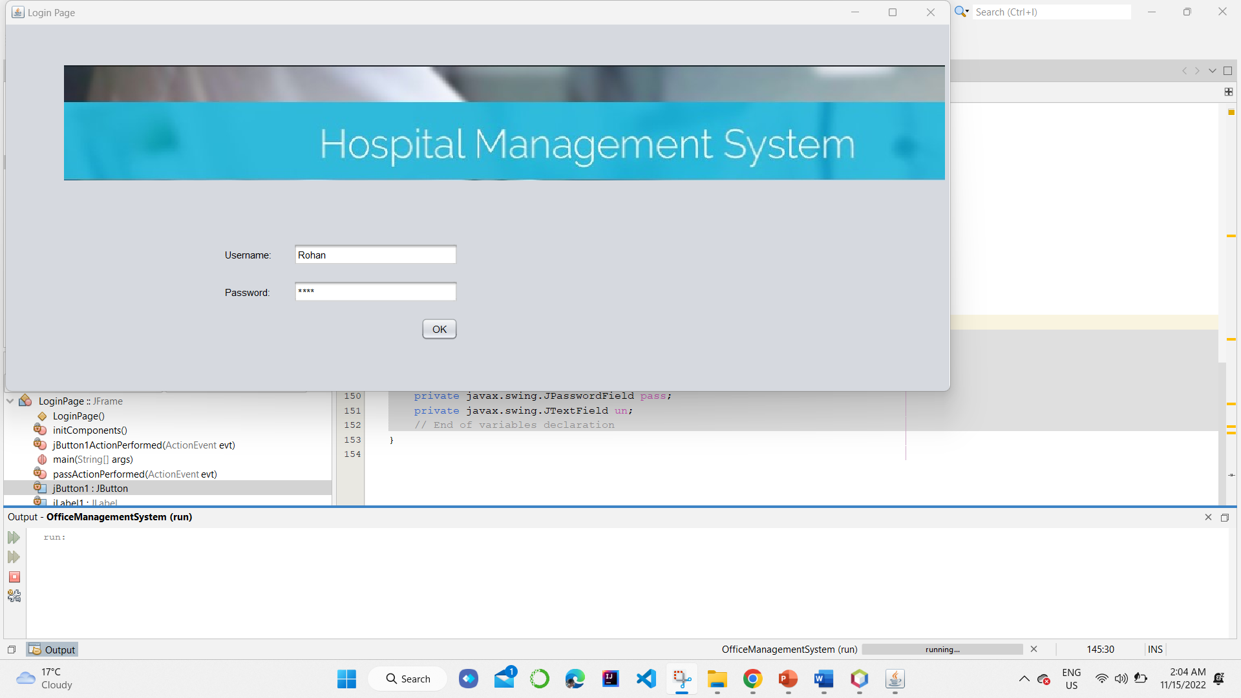**

**(Snapshot -3)**

Menu-driven page of declaring the options:

* Patient form
* Doctor availability.

**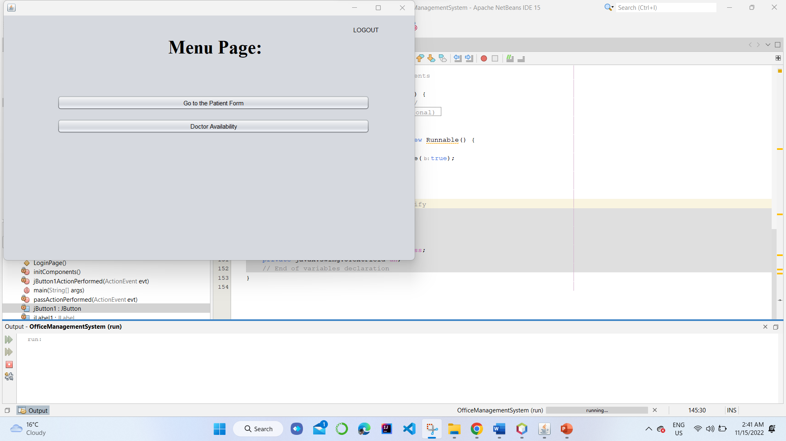**

**(Snapshot -4)**

The first menu with the form for entering the patient details, along with successfully entry of details.

**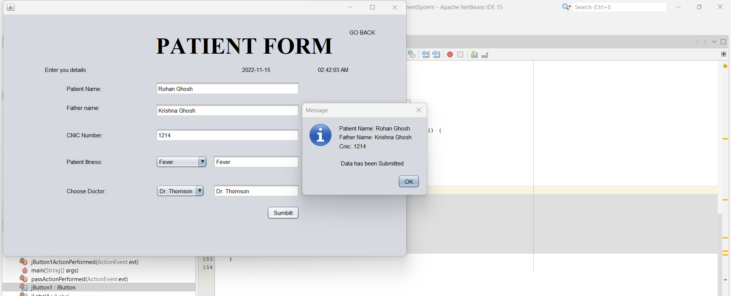**

**(Snapshot -5)**

The second menu i.e., doctor availability page showing the real time doctors available, along with confirmation of booking.

**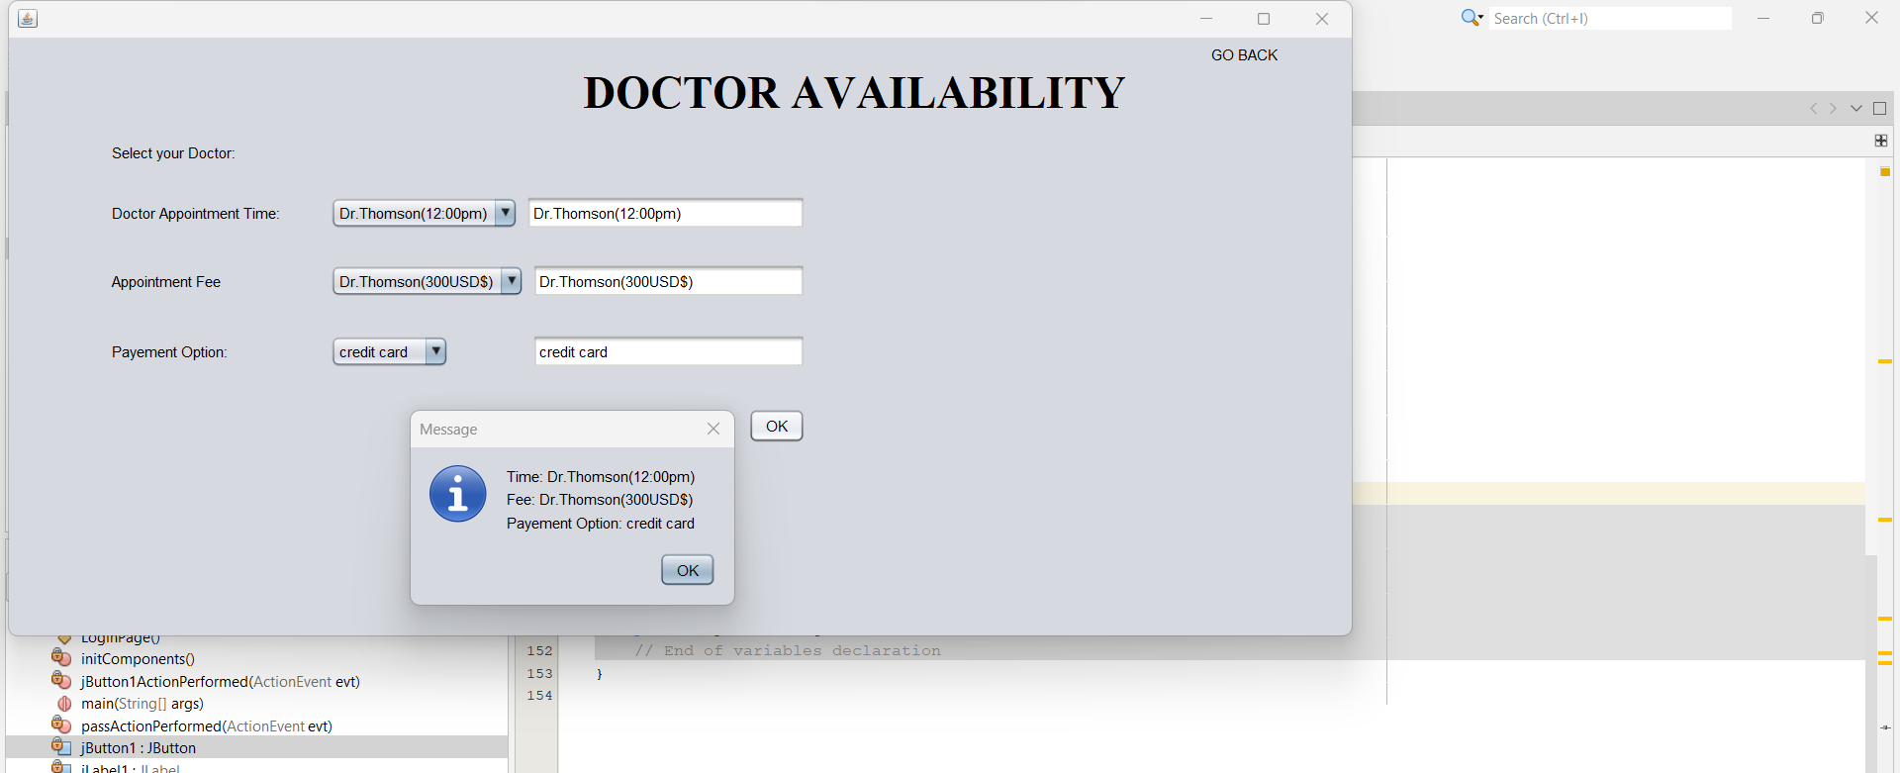**

# DISCUSSION OR REPORT/RESULT ANALYSIS

Healthcare software development or healthcare app development is the process of developing an app for mobile devices to help its users successfully track and follow their health issues in real time. For instance, mobile health application development is a big yes for [EHR (Electronic Health Records)](https://appinventiv.com/blog/impact-of-technology-on-ehr/), medical service experience, [hospital services](https://appinventiv.com/blog/6-reasons-why-your-hospital-needs-a-mobile-application/), [digitized medical insurance claims](https://appinventiv.com/blog/health-insurance-digitalization-benefits-and-tech-stack/) etc.

[Healthcare mobile apps](https://appinventiv.com/blog/mobile-apps-revolutionizing-health-fitness-industry/) development serves different purposes:

* For Doctors and medical professionals- It helps in monitoring, patient tracking, staff management, appointment scheduling etc.
* For patients- mHealth app development is to track wellbeing, seek medical recommendations and book appointments.

Mobile healthcare apps allow users to access a plethora of information and a variety of medical health facilities with a few simple taps on their mobile devices. Not to forget that healthcare professionals also use mHealth apps to consult patients on video and audio conferencing, make diagnosis and prescribe medicines.

An Accenture survey revealed that [75% of the users](https://www.accenture.com/us-en/insights/health/leaders-make-recent-digital-health-gains-last?utm_source=newsletter&utm_medium=email&utm_campaign=newsletter_axiosvitals&stream=top-stories) are already well aware of the purpose and uses of healthcare based app development.

While we are talking about medical and healthcare applications, you can often get confused between them.

### **Benefits for medical professionals:**

Developing a healthcare app is a time consuming and often expensive process, however it proves extensive value to its investors and stakeholders in:

* **Faster decision making-** When professionals have integrated medical records of patients through healthcare apps, they are faster with decisions and prescriptions.
* **Accurate diagnosis-** With accurate diagnosis comes better treatment plans, timely healthcare delivery and effective outcomes. For instance, [VisualDx](https://www.visualdx.com/" \t "_blank) is among top diagnostic support systems and healthcare apps for personalized guidance.
* **Improved communication-** Various telehealth application platforms help doctors connect with each other remotely for important consultations and discussions.
* **Less stress and burnout-**Application and healthcare software development frees professionals from mundane tasks by increasing the reliability of medical systems and processes. It is surprising to see how removal of paperwork from hospitals and medical centers resulted in [61% increased productivity](https://www.forbes.com/sites/adigaskell/2020/12/08/productivity-in-times-of-covid/?sh=14b3181c1fa1) among doctors and staff.
* **Better service and equipment management** – Modern equipped technologies allow healthcare organizations to track equipment in real time and optimize its use accordingly. For instance, developing a healthcare application to track all active on-premise ventilators.
* **Overall reduced cost of healthcare provision** – All the benefits mentioned above, add up to the overall cost reduction of healthcare provision and service.

### **Benefits for general users:**

* **High quality care** – Along with all automation available to providers, users can receive personal health plans and solutions that respect their specific medical needs.
* **Accessible healthcare data** – A healthcare mobile app platform can export medical records and share them over to medical services for better monitoring. For instance, [UpToDate](https://www.wolterskluwer.com/en/solutions/uptodate/uptodate/mobile) is a mobile healthcare app that tracks workflow, medical news, healthKit and daily achievements of users.
* **On-demand accessible care** – Mobile app development for healthcare makes on demand medical services accessible. It’s like ordering a bowl of sushi from your nearby restaurants with a few clicks. This means the care gets delivered faster including drug delivery and prescriptions.
* **Secure payments** – In-app payments with credit cards are applicable and super secure with healthcare software development. Speaking of secure, [Blockchain for healthcare](https://appinventiv.com/blog/blockchain-technology-in-healthcare-industry/)can also be used to perform transactions.
* **Better communication** – There are medical apps that are specifically used in hospitals for maintaining real time communication with patients. E-health solutions, healthcare software development and application platforms give users more control over their therapy making them active participants in the digital healthcare space. The more engagement from customers means more opportunities for businesses to develop healthcare mobile app solutions.

# PROJECT MANAGEMENT AND PROFESSIONAL COMMUNICATION

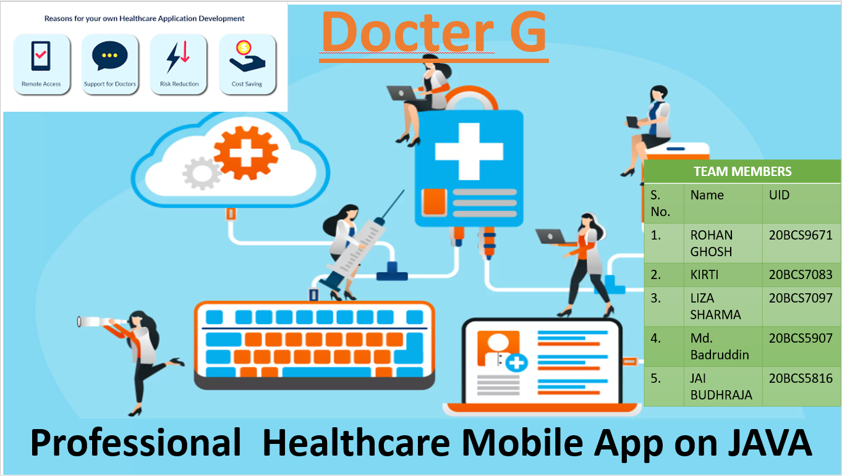

## SLIDE 1

**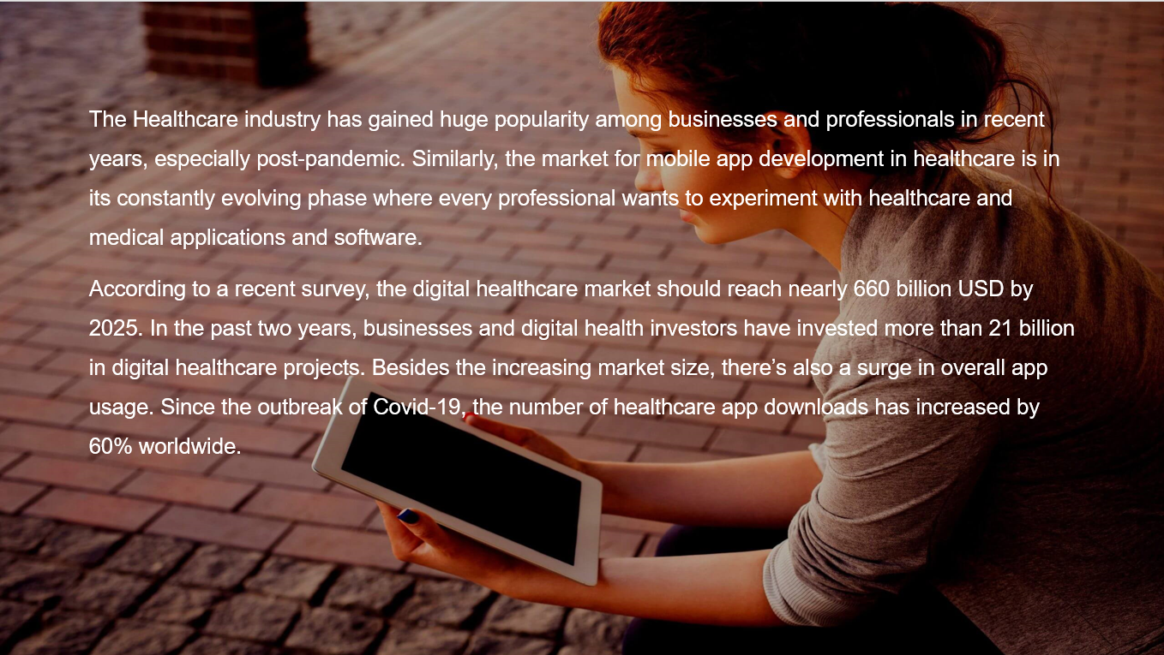**

**SLIDE 2**

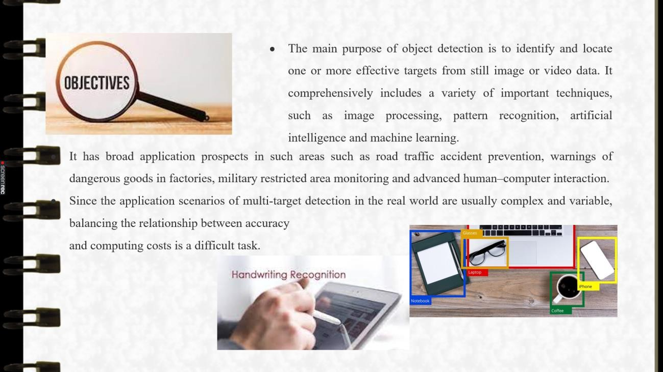

## SLIDE 3

**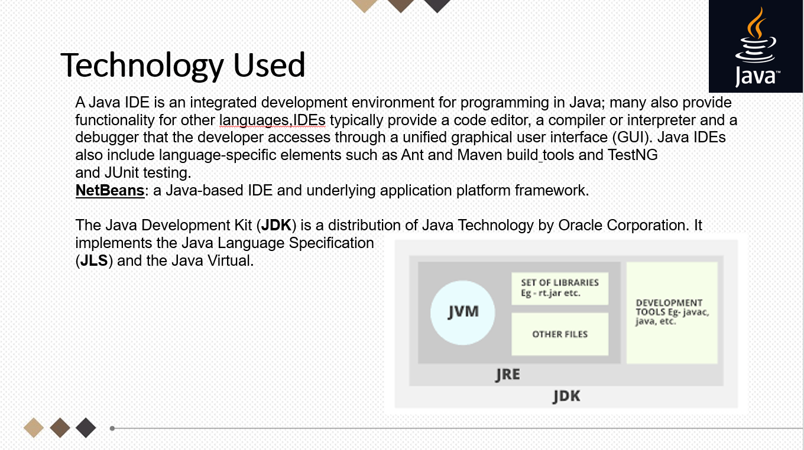**

**SLIDE 4**

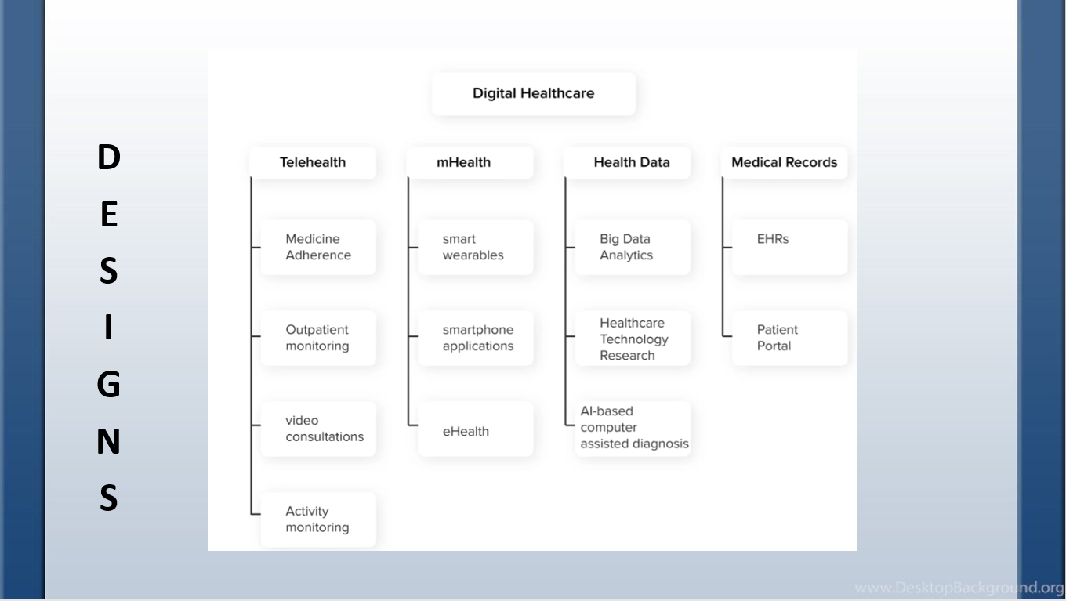

## SLIDE 5

**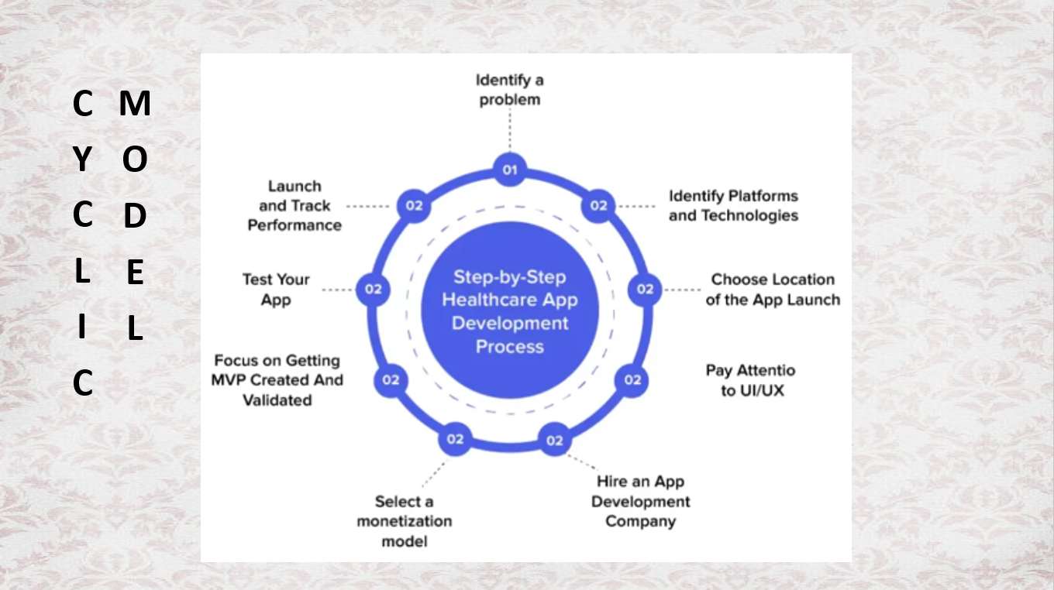**

**SLIDE 6**

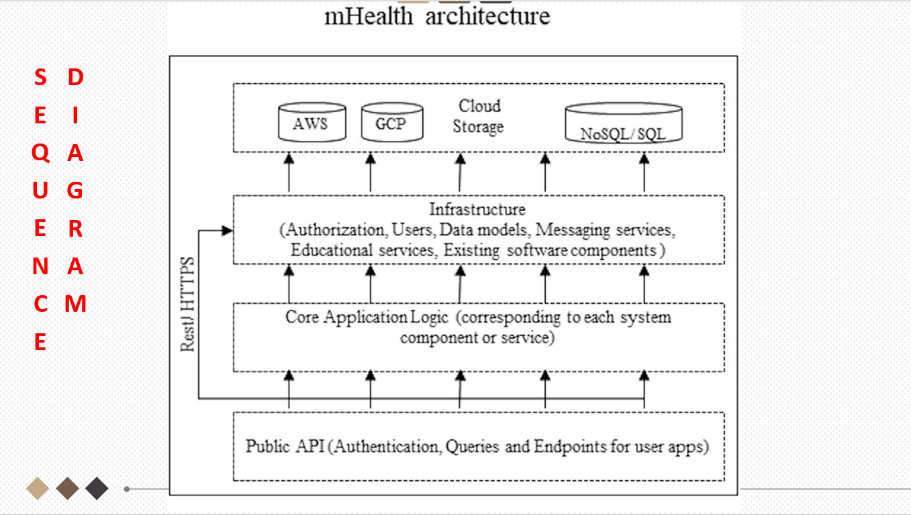

## SLIDE 7

**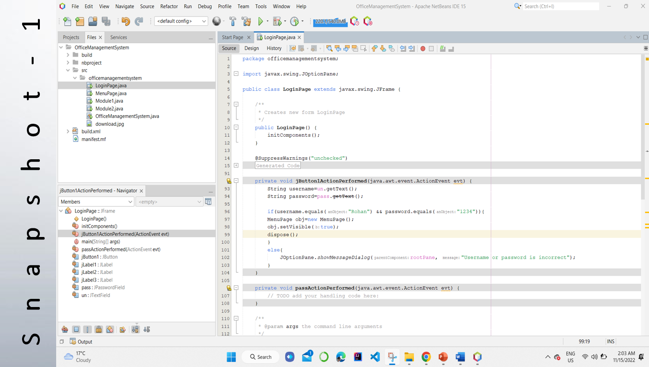**

**SLIDE 8**

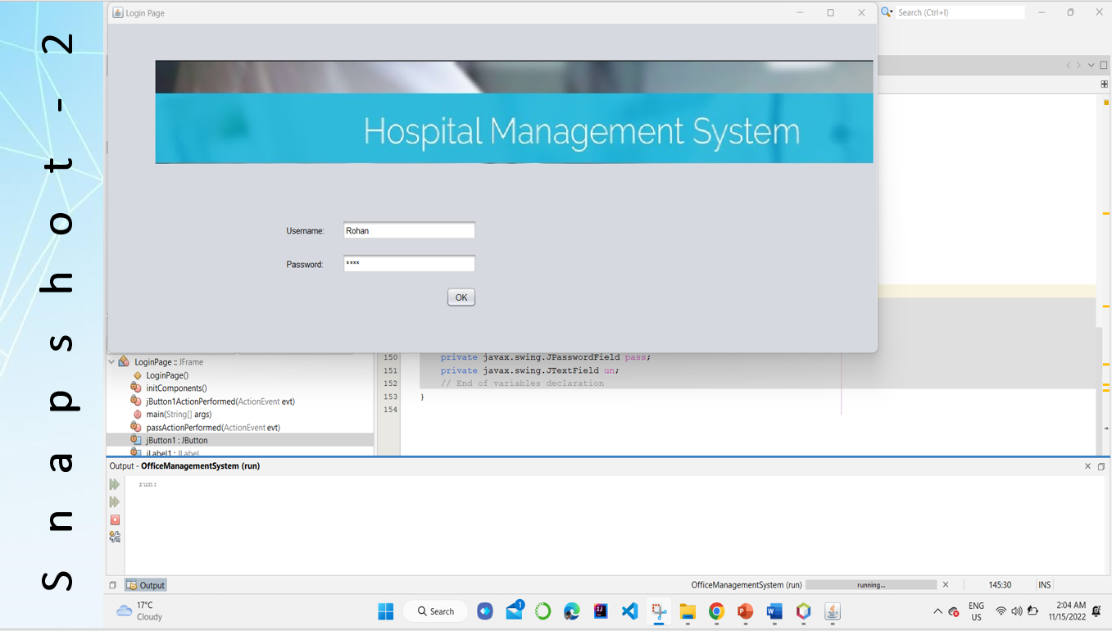

## SLIDE 9

**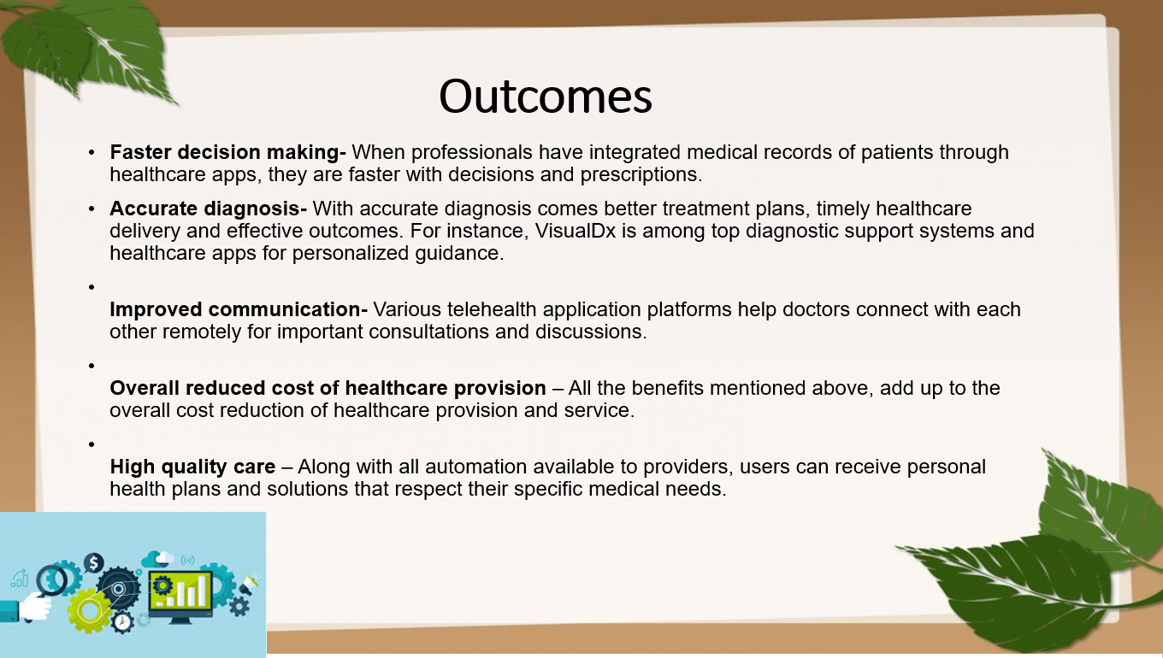**

**SLIDE 10**

# ATTAINMENT OF STATED OUTCOMES

# A healthcare mobile app is an effective tool to attract users as well as streamline the hospital’s functioning. From registering to discharging the patient, these healthcare and medical apps help you perform different operations easily and effectively.

# Below are a few trending uses of healthcare apps to boost your business functionality and improve overall patient care.

### **1. Electronic Health Record (EHR)**

With the [integration of EHR solutions](https://appinventiv.com/blog/ehr-optimization-for-better-healthcare-guide/), healthcare apps can easily track, store, and collect all information related to a patient on a single platform. This saves time, eliminates errors, and allows the exchange of patient data between different healthcare institutions.

### **2. Telehealth and Telemedicine**

The use of telemedicine and telehealth software solutions such as [SaMD (Software as a medical device)](https://appinventiv.com/blog/software-as-a-medical-device-regulation/) and more, between a patient and doctor is in high demand today. Such applications have become especially popular after the COVID-19 pandemic and social isolation.

These technologies allow healthcare professionals to deliver remote healthcare services, communicate online and offer top-notch medical care faster.

Doctor-on-demand is one such application that allows healthcare professionals to offer consultations via video or audio calls. It also helps patients to book appointments at their convenience.

### **3. Built-in diagnostic systems**

These systems enable the collection and processing of the data from embedded and [IoT devices](https://appinventiv.com/blog/what-is-internet-of-things/) integrated with EHR platforms. The doctors can easily analyse and diagnose the condition of remote patients, track progress, and determine treatment.

### **4. E-prescribing**

E-prescribing apps allow doctors to prescribe the right medicines for patients and set dosages to avoid side effects or cancel prescriptions at any time. These systems help in minimizing errors during check-out and the time that a doctor and a patient can save.

For instance, Medscape is one such app that allows doctors to upload prescriptions in the app itself according to the patient’s requirements.

By now, we have all the information required on the whereabouts of mobile app development for healthcare. We can now finally move to the mobile healthcare software and app development process. While the initial development process begins with the healthcare app idea itself, there are few factors you must know before starting the actual mobile app development for healthcare.

# REFERENCES

1. DeGusta M. Are smart phones spreading faster than any technology in human history. Massachusetts Institute of Technology Review, 2012. [[Google Scholar](https://scholar.google.com/scholar?q=DeGusta+M.+Are+smart+phones+spreading+faster+than+any+technology+in+human+history.+Massachusetts+Institute+of+Technology+Review,+2012.+)]

2. Smith A. Record shares of Americans now own smartphones, have home broadband. *Pew Research Center* 2017; 12:1-2. [[Google Scholar](https://scholar.google.com/scholar_lookup?journal=Pew+Research+Center&title=Record+shares+of+Americans+now+own+smartphones,+have+home+broadband.&author=A.+Smith&volume=12&publication_year=2017&pages=1-2&)]

3. Center PR. Mobile fact sheet. Pew Research Center: Internet, *Science & Tech*, 2017. [[Google Scholar](https://scholar.google.com/scholar_lookup?journal=Science+&+Tech&title=Mobile+fact+sheet.+Pew+Research+Center:+Internet&author=PR+Center&publication_year=2017&)]

4. Taylor K, Silver L. Smartphone Ownership is Growing Rapidly Around the World, but Not Always Equally. 2018. Available online: <https://www.pewresearch.org/global/2019/02/05/smartphone-ownership-is-growing-rapidly-around-the-world-but-not-always-equally/>

5. Lenhart A, Duggan M, Perrin A, et al. Teens, social media & technology overview 2015. Pew Research Center: Internet & American Life Project, 2015.

6. Twenge JM, Martin GN, Campbell WK. Decreases in psychological well-being among American adolescents after 2012 and links to screen time during the rise of smartphone technology. *Emotion* 2018; 18:765-80. 10.1037/emo0000403 [[PubMed](https://pubmed.ncbi.nlm.nih.gov/29355336)] [[CrossRef](https://doi.org/10.1037%2Femo0000403" \t "_blank)] [[Google Scholar](https://scholar.google.com/scholar_lookup?journal=Emotion&title=Decreases+in+psychological+well-being+among+American+adolescents+after+2012+and+links+to+screen+time+during+the+rise+of+smartphone+technology.&author=JM+Twenge&author=GN+Martin&author=WK+Campbell&volume=18&publication_year=2018&pages=765-80&pmid=29355336&doi=10.1037/emo0000403&)]

7. Twenge JM, Campbell WK. Associations between screen time and lower psychological well-being among children and adolescents: Evidence from a population-based study. *Prev Med Rep* 2018;12:271-83. 10.1016/j.pmedr.2018.10.003 [[PMC free article](https://www.ncbi.nlm.nih.gov/pmc/articles/PMC6214874/)] [[PubMed](https://pubmed.ncbi.nlm.nih.gov/30406005)] [[CrossRef](https://doi.org/10.1016%2Fj.pmedr.2018.10.003" \t "_blank)] [[Google Scholar](https://scholar.google.com/scholar_lookup?journal=Prev+Med+Rep&title=Associations+between+screen+time+and+lower+psychological+well-being+among+children+and+adolescents:+Evidence+from+a+population-based+study.&author=JM+Twenge&author=WK+Campbell&volume=12&publication_year=2018&pages=271-83&pmid=30406005&doi=10.1016/j.pmedr.2018.10.003&)]

8. Peracchia S, Curcio G. Exposure to video games: effects on sleep and on post-sleep cognitive abilities. A systematic review of experimental evidences. *Sleep Sci* 2018;11:302-14. 10.5935/1984-0063.20180046 [[PMC free article](https://www.ncbi.nlm.nih.gov/pmc/articles/PMC6361300/)] [[PubMed](https://pubmed.ncbi.nlm.nih.gov/30746049)] [[CrossRef](https://doi.org/10.5935%2F1984-0063.20180046" \t "_blank)] [[Google Scholar](https://scholar.google.com/scholar_lookup?journal=Sleep+Sci&title=Exposure+to+video+games:+effects+on+sleep+and+on+post-sleep+cognitive+abilities.+A+sistematic+review+of+experimental+evidences.&author=S+Peracchia&author=G+Curcio&volume=11&publication_year=2018&pages=302-14&pmid=30746049&doi=10.5935/1984-0063.20180046&)]

9. Tofighi B, Abrantes A, Stein MD. The Role of Technology-Based Interventions for Substance Use Disorders in Primary Care: A Review of the Literature. *Med Clin North Am* 2018;102:715-31. 10.1016/j.mcna.2018.02.011 [[PMC free article](https://www.ncbi.nlm.nih.gov/pmc/articles/PMC6563611/)] [[PubMed](https://pubmed.ncbi.nlm.nih.gov/29933825)] [[CrossRef](https://doi.org/10.1016%2Fj.mcna.2018.02.011" \t "_blank)] [[Google Scholar](https://scholar.google.com/scholar_lookup?journal=Med+Clin+North+Am&title=The+Role+of+Technology-Based+Interventions+for+Substance+Use+Disorders+in+Primary+Care:+A+Review+of+the+Literature.&author=B+Tofighi&author=A+Abrantes&author=MD+Stein&volume=102&publication_year=2018&pages=715-31&pmid=29933825&doi=10.1016/j.mcna.2018.02.011&)]

10. Moman RN, Dvorkin J, Pollard EM, et al. A Systematic Review and Meta-analysis of Unguided Electronic and Mobile Health Technologies for Chronic Pain-Is It Time to Start Prescribing Electronic Health Applications?. *Pain Med* 2019;20:2238-55. 10.1093/pm/pnz164 [[PubMed](https://pubmed.ncbi.nlm.nih.gov/31386151)] [[CrossRef](https://doi.org/10.1093%2Fpm%2Fpnz164" \t "_blank)] [[Google Scholar](https://scholar.google.com/scholar_lookup?journal=Pain+Med&title=A+Systematic+Review+and+Meta-analysis+of+Unguided+Electronic+and+Mobile+Health+Technologies+for+Chronic+Pain-Is+It+Time+to+Start+Prescribing+Electronic+Health+Applications?.&author=RN+Moman&author=J+Dvorkin&author=EM+Pollard&volume=20&publication_year=2019&pages=2238-55&pmid=31386151&doi=10.1093/pm/pnz164&)]

11. McCann L, McMillan KA, Pugh G. Digital Interventions to Support Adolescents and Young Adults With Cancer: Systematic Review. *JMIR Cancer* 2019;5:e12071. 10.2196/12071 [[PMC free article](https://www.ncbi.nlm.nih.gov/pmc/articles/PMC6693302/)] [[PubMed](https://pubmed.ncbi.nlm.nih.gov/31368438)] [[CrossRef](https://doi.org/10.2196%2F12071" \t "_blank)] [[Google Scholar](https://scholar.google.com/scholar_lookup?journal=JMIR+Cancer&title=Digital+Interventions+to+Support+Adolescents+and+Young+Adults+With+Cancer:+Systematic+Review.&author=L+McCann&author=KA+McMillan&author=G+Pugh&volume=5&publication_year=2019&pages=e12071&pmid=31368438&doi=10.2196/12071&)]

12. Naslund JA, Aschbrenner KA, Araya R, et al. Digital technology for treating and preventing mental disorders in low-income and middle-income countries: a narrative review of the literature. *Lancet Psychiatry* 2017;4:486-500. 10.1016/S2215-0366(17)30096-2 [[PMC free article](https://www.ncbi.nlm.nih.gov/pmc/articles/PMC5523650/)] [[PubMed](https://pubmed.ncbi.nlm.nih.gov/28433615)] [[CrossRef](https://doi.org/10.1016%2FS2215-0366(17)30096-2" \t "_blank)] [[Google Scholar](https://scholar.google.com/scholar_lookup?journal=Lancet+Psychiatry&title=Digital+technology+for+treating+and+preventing+mental+disorders+in+low-income+and+middle-income+countries:+a+narrative+review+of+the+literature.&author=JA+Naslund&author=KA+Aschbrenner&author=R+Araya&volume=4&publication_year=2017&pages=486-500&pmid=28433615&doi=10.1016/S2215-0366(17)30096-2&)]

13. Kaner EF, Beyer FR, Garnett C, et al. Personalized digital interventions for reducing hazardous and harmful alcohol consumption in community-dwelling populations. *Cochrane Database Syst Rev* 2017;9:CD011479. 10.1002/14651858.CD011479.pub2 [[PMC free article](https://www.ncbi.nlm.nih.gov/pmc/articles/PMC6483779/)] [[PubMed](https://pubmed.ncbi.nlm.nih.gov/28944453)] [[CrossRef](https://doi.org/10.1002%2F14651858.CD011479.pub2" \t "_blank)] [[Google Scholar](https://scholar.google.com/scholar_lookup?journal=Cochrane+Database+Syst+Rev&title=Personalised+digital+interventions+for+reducing+hazardous+and+harmful+alcohol+consumption+in+community-dwelling+populations.&author=EF+Kaner&author=FR+Beyer&author=C+Garnett&volume=9&publication_year=2017&pages=CD011479&pmid=28944453&doi=10.1002/14651858.CD011479.pub2&)]

14. Nesvåg S, McKay JR. Feasibility and Effects of Digital Interventions to Support People in Recovery From Substance Use Disorders: Systematic Review. *J Med Internet Res* 2018;20:e255. 10.2196/jmir.9873 [[PMC free article](https://www.ncbi.nlm.nih.gov/pmc/articles/PMC6127498/)] [[PubMed](https://pubmed.ncbi.nlm.nih.gov/30139724)] [[CrossRef](https://doi.org/10.2196%2Fjmir.9873" \t "_blank)] [[Google Scholar](https://scholar.google.com/scholar_lookup?journal=J+Med+Internet+Res&title=Feasibility+and+Effects+of+Digital+Interventions+to+Support+People+in+Recovery+From+Substance+Use+Disorders:+Systematic+Review.&author=S+Nesv%C3%A5g&author=JR+McKay&volume=20&publication_year=2018&pages=e255&pmid=30139724&doi=10.2196/jmir.9873&)]

15. Harari GM, Lane ND, Wang R, et al. Using Smartphones to Collect Behavioral Data in Psychological Science: Opportunities, Practical Considerations, and Challenges. *Perspex Psychol Sci* 2016;11:838-54. 10.1177/1745691616650285 [[PMC free article](https://www.ncbi.nlm.nih.gov/pmc/articles/PMC5572675/)] [[PubMed](https://pubmed.ncbi.nlm.nih.gov/27899727)] [[CrossRef](https://doi.org/10.1177%2F1745691616650285" \t "_blank)] [[Google Scholar](https://scholar.google.com/scholar_lookup?journal=Perspect+Psychol+Sci&title=Using+Smartphones+to+Collect+Behavioral+Data+in+Psychological+Science:+Opportunities,+Practical+Considerations,+and+Challenges.&author=GM+Harari&author=ND+Lane&author=R+Wang&volume=11&publication_year=2016&pages=838-54&pmid=27899727&doi=10.1177/1745691616650285&)]

16. Buller DB, Berwick M, Lantz K, et al. Smartphone mobile application delivering personalized, real-time sun protection advice: a randomized clinical trial. *JAMA Dermatol* 2015;151:497-504. 10.1001/jamadermatol.2014.3889 [[PMC free article](https://www.ncbi.nlm.nih.gov/pmc/articles/PMC4431912/)] [[PubMed](https://pubmed.ncbi.nlm.nih.gov/25629710)] [[CrossRef](https://doi.org/10.1001%2Fjamadermatol.2014.3889" \t "_blank)] [[Google Scholar](https://scholar.google.com/scholar_lookup?journal=JAMA+Dermatol&title=Smartphone+mobile+application+delivering+personalized,+real-time+sun+protection+advice:+a+randomized+clinical+trial.&author=DB+Buller&author=M+Berwick&author=K+Lantz&volume=151&publication_year=2015&pages=497-504&pmid=25629710&doi=10.1001/jamadermatol.2014.3889&)]

17. Romeo A, Edney S, Plotnikoff R, et al. Can Smartphone Apps Increase Physical Activity? Systematic Review and Meta-Analysis. *J Med Internet Res* 2019;21:e12053. 10.2196/12053 [[PMC free article](https://www.ncbi.nlm.nih.gov/pmc/articles/PMC6444212/)] [[PubMed](https://pubmed.ncbi.nlm.nih.gov/30888321)] [[CrossRef](https://doi.org/10.2196%2F12053" \t "_blank)] [[Google Scholar](https://scholar.google.com/scholar_lookup?journal=J+Med+Internet+Res&title=Can+Smartphone+Apps+Increase+Physical+Activity?+Systematic+Review+and+Meta-Analysis.&author=A+Romeo&author=S+Edney&author=R+Plotnikoff&volume=21&publication_year=2019&pages=e12053&pmid=30888321&doi=10.2196/12053&)]

18. Ciman M, Wac K. Smartphones as Sleep Duration Sensors: Validation of the iSenseSleep Algorithm. *JMIR Mhealth Uhealth* 2019;7:e11930. 10.2196/11930 [[PMC free article](https://www.ncbi.nlm.nih.gov/pmc/articles/PMC6547769/)] [[PubMed](https://pubmed.ncbi.nlm.nih.gov/31115341)] [[CrossRef](https://doi.org/10.2196%2F11930" \t "_blank)] [[Google Scholar](https://scholar.google.com/scholar_lookup?journal=JMIR+Mhealth+Uhealth&title=Smartphones+as+Sleep+Duration+Sensors:+Validation+of+the+iSenseSleep+Algorithm.&author=M+Ciman&author=K.+Wac&volume=7&publication_year=2019&pages=e11930&pmid=31115341&doi=10.2196/11930&)]

19. LeGrand S, Muessig KE, McNulty T, et al. Epic Allies: Development of a Gaming App to Improve Antiretroviral Therapy Adherence Among Young HIV-Positive Men Who Have Sex With Men. *JMIR Serious Games* 2016;4:e6. 10.2196/games.5687 [[PMC free article](https://www.ncbi.nlm.nih.gov/pmc/articles/PMC4884268/)] [[PubMed](https://pubmed.ncbi.nlm.nih.gov/27178752)] [[CrossRef](https://doi.org/10.2196%2Fgames.5687" \t "_blank)] [[Google Scholar](https://scholar.google.com/scholar_lookup?journal=JMIR+Serious+Games&title=Epic+Allies:+Development+of+a+Gaming+App+to+Improve+Antiretroviral+Therapy+Adherence+Among+Young+HIV-Positive+Men+Who+Have+Sex+With+Men.&author=S+LeGrand&author=KE+Muessig&author=T+McNulty&volume=4&publication_year=2016&pages=e6&pmid=27178752&doi=10.2196/games.5687&)]

20. Henny KD, Wilkes AL, McDonald CM, et al. A rapid review of eHealth interventions addressing the continuum of HIV care (2007–2017). *AIDS and Behavior* 2018;22:43-63. 10.1007/s10461-017-1923-2 [[PMC free article](https://www.ncbi.nlm.nih.gov/pmc/articles/PMC5760442/)] [[PubMed](https://pubmed.ncbi.nlm.nih.gov/28983684)] [[CrossRef](https://doi.org/10.1007%2Fs10461-017-1923-2" \t "_blank)] [[Google Scholar](https://scholar.google.com/scholar_lookup?journal=AIDS+and+Behavior&title=A+rapid+review+of+eHealth+interventions+addressing+the+continuum+of+HIV+care+(2007%E2%80%932017).&author=KD+Henny&author=AL+Wilkes&author=CM+McDonald&volume=22&publication_year=2018&pages=43-63&pmid=28983684&doi=10.1007/s10461-017-1923-2&)]

21. Schoeppe S, Alley S, Rebar AL, et al. Apps to improve diet, physical activity and sedentary behaviour in children and adolescents: a review of quality, features and behaviour change techniques. *Int J Behav Nutr Phys Act* 2017;14:83. 10.1186/s12966-017-0538-3 [[PMC free article](https://www.ncbi.nlm.nih.gov/pmc/articles/PMC5483249/)] [[PubMed](https://pubmed.ncbi.nlm.nih.gov/28646889)] [[CrossRef](https://doi.org/10.1186%2Fs12966-017-0538-3" \t "_blank)] [[Google Scholar](https://scholar.google.com/scholar_lookup?journal=Int+J+Behav+Nutr+Phys+Act&title=Apps+to+improve+diet,+physical+activity+and+sedentary+behaviour+in+children+and+adolescents:+a+review+of+quality,+features+and+behaviour+change+techniques.&author=S+Schoeppe&author=S+Alley&author=AL+Rebar&volume=14&publication_year=2017&pages=83&pmid=28646889&doi=10.1186/s12966-017-0538-3&)]

22. Greer JA, Jacobs JM, Pensak N, et al. Randomized Trial of a Smartphone Mobile App to Improve Symptoms and Adherence to Oral Therapy for Cancer. *J Natl Compr Canc Netw* 2020;18:133-41. [[PubMed](https://pubmed.ncbi.nlm.nih.gov/32023526)] [[Google Scholar](https://scholar.google.com/scholar_lookup?journal=J+Natl+Compr+Canc+Netw&title=Randomized+Trial+of+a+Smartphone+Mobile+App+to+Improve+Symptoms+and+Adherence+to+Oral+Therapy+for+Cancer.&author=JA+Greer&author=JM+Jacobs&author=N+Pensak&volume=18&publication_year=2020&pages=133-41&pmid=32023526&)]

23. Thirumalai M, Rimmer JH, Johnson G, et al. TEAMS (Tele-Exercise and Multiple Sclerosis), a Tailored Telerehabilitation mHealth App: Participant-Centered Development and Usability Study. *JMIR Mhealth Uhealth* 2018;6:e10181. 10.2196/10181 [[PMC free article](https://www.ncbi.nlm.nih.gov/pmc/articles/PMC5992455/)] [[PubMed](https://pubmed.ncbi.nlm.nih.gov/29798832)] [[CrossRef](https://doi.org/10.2196%2F10181" \t "_blank)] [[Google Scholar](https://scholar.google.com/scholar_lookup?journal=JMIR+Mhealth+Uhealth&title=TEAMS+(Tele-Exercise+and+Multiple+Sclerosis),+a+Tailored+Telerehabilitation+mHealth+App:+Participant-Centered+Development+and+Usability+Study.&author=M+Thirumalai&author=JH+Rimmer&author=G+Johnson&volume=6&publication_year=2018&pages=e10181&pmid=29798832&doi=10.2196/10181&)]

24. Tate EB, Spruijt-Metz D, O'Reilly G, et al. mHealth approaches to child obesity prevention: successes, unique challenges, and next directions. *Transl Behav Med* 2013;3:406-15. 10.1007/s13142-013-0222-3 [[PMC free article](https://www.ncbi.nlm.nih.gov/pmc/articles/PMC3830013/)] [[PubMed](https://pubmed.ncbi.nlm.nih.gov/24294329)] [[CrossRef](https://doi.org/10.1007%2Fs13142-013-0222-3" \t "_blank)] [[Google Scholar](https://scholar.google.com/scholar_lookup?journal=Transl+Behav+Med&title=mHealth+approaches+to+child+obesity+prevention:+successes,+unique+challenges,+and+next+directions.&author=EB+Tate&author=D+Spruijt-Metz&author=G+O%27Reilly&volume=3&publication_year=2013&pages=406-15&pmid=24294329&doi=10.1007/s13142-013-0222-3&)]

25. Villanti AC, Johnson AL, Ilakkuvan V, et al. Social Media Use and Access to Digital Technology in US Young Adults in 2016. *J Med Internet Res* 2017;19:e196. 10.2196/jmir.7303 [[PMC free article](https://www.ncbi.nlm.nih.gov/pmc/articles/PMC5480010/)] [[PubMed](https://pubmed.ncbi.nlm.nih.gov/28592394)] [[CrossRef](https://doi.org/10.2196%2Fjmir.7303" \t "_blank)] [[Google Scholar](https://scholar.google.com/scholar_lookup?journal=J+Med+Internet+Res&title=Social+Media+Use+and+Access+to+Digital+Technology+in+US+Young+Adults+in+2016.&author=AC+Villanti&author=AL+Johnson&author=V+Ilakkuvan&volume=19&publication_year=2017&pages=e196&pmid=28592394&doi=10.2196/jmir.7303&)]

26. Laing SS, Alsayid M, Ocampo C, et al. Mobile Health Technology Knowledge and Practices Among Patients of Safety-Net Health Systems in Washington State and Washington, DC. *J Patient Cent Res Rev* 2018;5:204-17. 10.17294/2330-0698.1622 [[PMC free article](https://www.ncbi.nlm.nih.gov/pmc/articles/PMC6664329/)] [[PubMed](https://pubmed.ncbi.nlm.nih.gov/31414005)] [[CrossRef](https://doi.org/10.17294%2F2330-0698.1622" \t "_blank)] [[Google Scholar](https://scholar.google.com/scholar_lookup?journal=J+Patient+Cent+Res+Rev&title=Mobile+Health+Technology+Knowledge+and+Practices+Among+Patients+of+Safety-Net+Health+Systems+in+Washington+State+and+Washington,+DC.&author=SS+Laing&author=M+Alsayid&author=C+Ocampo&volume=5&publication_year=2018&pages=204-17&pmid=31414005&doi=10.17294/2330-0698.1622&)]

27. Akinola M, Hebert LE, Hill BJ, et al. Development of a Mobile App on Contraceptive Options for Young African American and Latina Women. *Health Educ Behav* 2019;46:89-96. 10.1177/1090198118775476 [[PubMed](https://pubmed.ncbi.nlm.nih.gov/29896969)] [[CrossRef](https://doi.org/10.1177%2F1090198118775476" \t "_blank)] [[Google Scholar](https://scholar.google.com/scholar_lookup?journal=Health+Educ+Behav&title=Development+of+a+Mobile+App+on+Contraceptive+Options+for+Young+African+American+and+Latina+Women.&author=M+Akinola&author=LE+Hebert&author=BJ+Hill&volume=46&publication_year=2019&pages=89-96&pmid=29896969&doi=10.1177/1090198118775476&)]